Module Assembly - Contest Fee Based on % of Member Cost Admin Part Deployment Guide

Revision History
Author | Revision Number | Date
minhu | 1 | 2012-03-01

1. Organization of Submission 3
2. Application Setup 3
3. Ant .Properties File for direct project 3
4. Build scripts Setup 3
5. Deployment Instructions 3
6. Starting 4
7. Verification 4
8. Resource Contact List 6

Organization of Submission
- project: the folder for updated/new files of direct project
- doc: this folder for deployment guide, it contains this file Deployment_Guide.doc
- sql: the folder for ddl sql file

Application Setup

The application is expected to be deployed to the following environment:

- JRE 1.5
- JBoss 4.2.3.GA
- Informix DS 11.0

Ant .Properties File for direct project
- There’s no change in ant properties file of the current direct project.

Build scripts Setup
The build script for Direct application (build.xml) provides the following targets which are to be used:

- switch-and-checkout –checkout or switch to the defined source code branches for all components defined in subprojects.xml
- dist-backend –rebuilt all the components from the source code.
- first_deploy –must be the first task to execute from command line. It will copy all dependencies to your local JBoss folder.
- deploy –should be the main task to execute from command line. It will build and deploy WAR file.
- deploy-apache-static –deploys the static files to jboss.

Deployment Instructions

This section provides the instructions in VM environment.

- Follow above setup sections.
- Merge the code from the submission project folder into SVN branch for Direct application.
- Rebuild component client_project_entities_dao using ant dist-backend
- Build and deploy Direct application using ant first_deploy command.
- Copy static files using ant deploy-apache-static command.
- Execute the sql/dll-update.sql to prepare database.

By default scorecard_tool war will be included in the ear and deployed, you can follow the steps below.
- Install grails, ref ScorecardDeploymentGuide.doc (under the trunk folder of scorecard_tool/docs).
Unzip it inside /home/direct folder (or any other folder). After that run the following commands:
export GRAILS_HOME=/home/direct/grails-1.3.7
export PATH=$PATH:$GRAILS_HOME/bin
- The application contains many wars, we need increase the memory limit to avoid memory problem:
export JAVA_OPTS=”-Xms512m –Xmx1024m –XX:PermSize=512m –XX:MaxPermSize=1024m”

Starting

- Build and deploy the Direct application (first ant dist-backend, then ant first_deploy, then ant deploy-apache-static)
- Start JBoss server instance hosting Direct application

Verification
After log in (heffan/password) the application redirected to page http://cockpit.cloud.topcoder.com/direct/dashboardActive.action

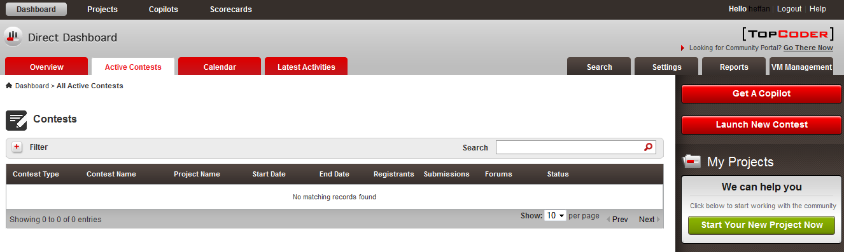
Click the Settings tab on the top-right. At the right top of the directed page, there’s select control “Select a Setting Panel”, choose “Contest Fee”, it directs to Contest Fee Management page.

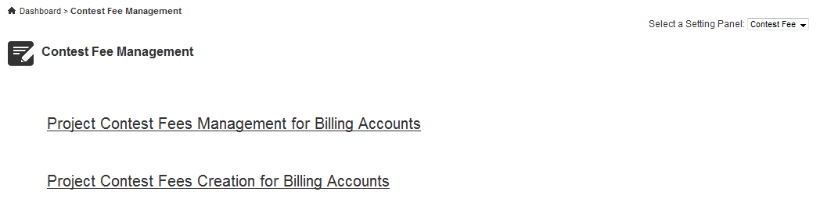

  - Verify create contest fee percentage.
Click the second link “Project Contest Fees Creation for Billing Accounts”.

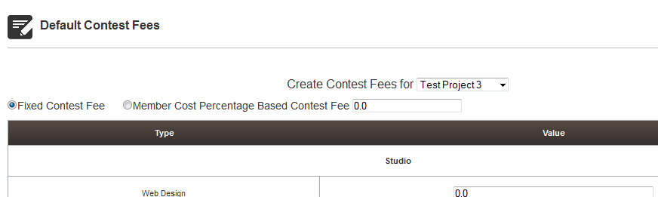

By default, “Fixed Contest Fee” radio button is selected.

You can select “Member Cost Percentage Based Contest Fee”, input something in the right text box then click the Submit button. If your input is not valid, an error message will be shown at the page top after server-side validation. (note the text in the right box will be ignored if “Fixed Contest Fee” is selected)

If you input non-number value, it displays:
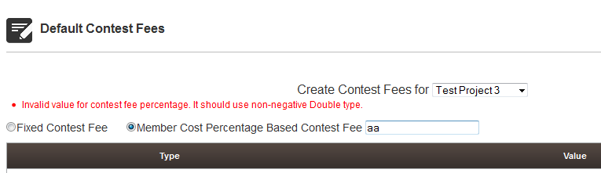

If you input value not in [0,1.0], it displays:
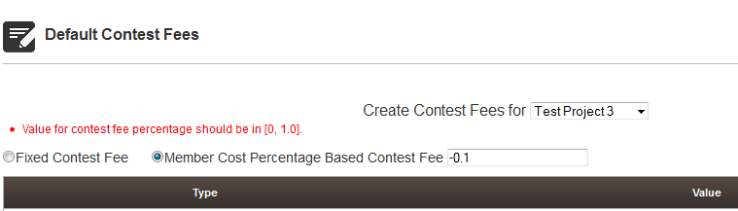

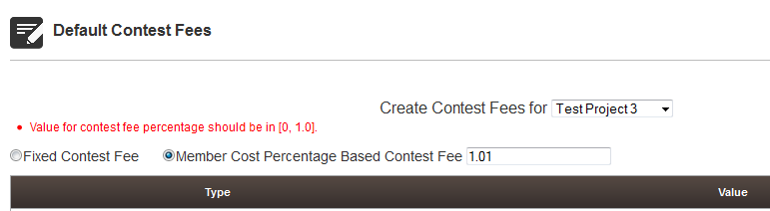

If the input is correct, the data will be saved and the page will be redirects back to Contest Fee Management page.

  - Verify edit contest fee percentage.
Click the second link “Project Contest Fees Management for Billing Accounts”. In the directed page, click the Billing Account link whose contest fee percentage we created in 7.1. (click Test Project3 if follow the page)

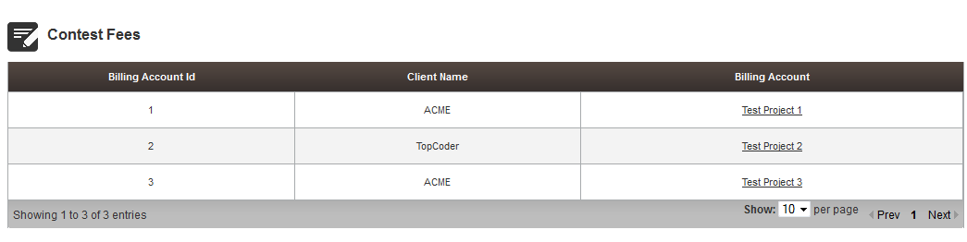

In the edit page, scroll to bottom, the percentage choice and value are same as set previously in 7.1.
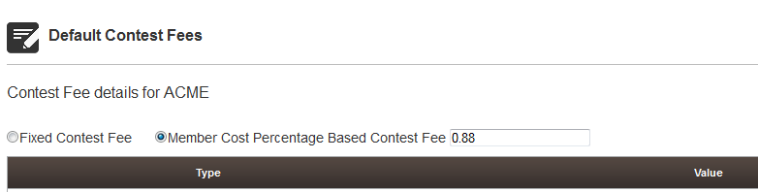

You can edit the percentage choice and value in this page like 7.1. The data will be updated and the page will be redirects back to Contest Fee Management page.

Resource Contact List

Name | Resource Email
TCSASSEMBLER

